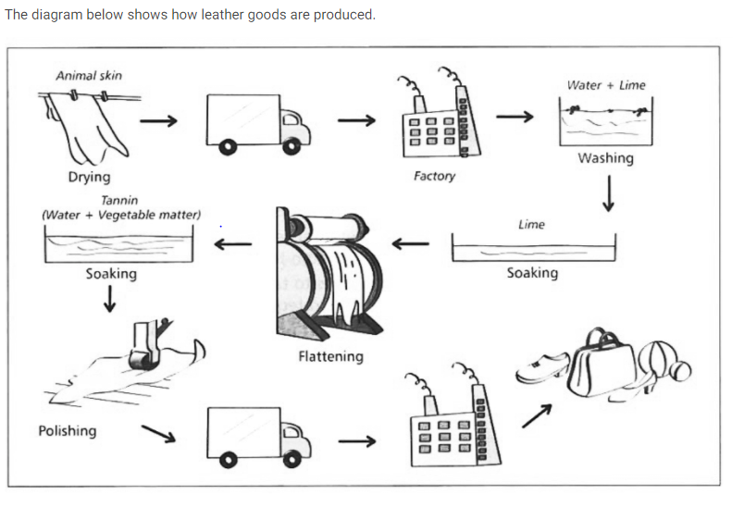

The diagram illustrates the process of manufacturing some kind of leather products. Overall, this process includes 11 stages, which starts with drying animal skin and ends with preparing goods. In this writing, we will explain these stages in the same order in the diagram.

First, animal skin must be dried and transported to the factory. In the factory, dried skin must be involved several subsequent process, such as: washing, soaking with lime, flattening, polishing and soaking with tannin before entering manufacturing process.

Then, the ready-for-used-skin would be transferred to another factory to be changed into variety type of goods such as shoes, handbags and different type of balls.

In sum up, the process of manufacturing of leather products is included 3 main stages. The first one is preparing a raw material, the second is processing a ready-for-used-skin and finally, assembling process. As we see in the diagram, the second step takes much longer than others do.