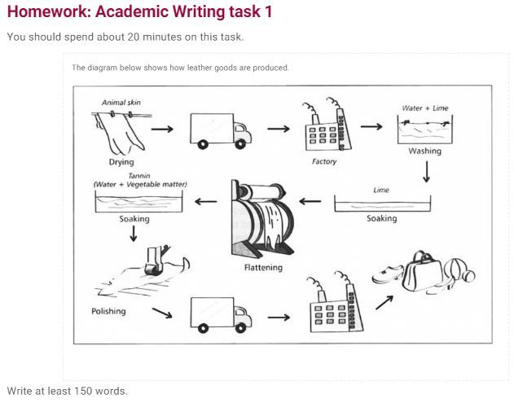

The process shown in the diagram illustrates how leader goods are produced. It is clear that there are eleven distinct steps in this process, from the initial drying animal skin to the eventual producing leather goods.

At the first stage in the leather producing process, animal skin is dried and then is moved to the factory. Subsequently, animal skin is washed in the mixture of water and lime and after this animal skin is soaked in the lime. Then, animal skin which was soaked in the lime, is flattened.

In the next step, flattened material is soaked in the tannin which contains water and vegetable matter. After soaking in the lime, flattening and soaking in the tannin, it is time for polishing. leather which was soaked in the tannin, is polished and then is moved by some vehicles to another factory. In the last stage, leather products as bags, shoes etc. are produced in that factory.

Word: 156

Time: 25

It was really hard for me to write 150 word in the process diagram. How can I increase words in process diagrams?