The pie charts below show the area and current population of the seven continents as a percentage of the total. Summarise the information by selecting and reporting the main features, and make comparisons where relevant.

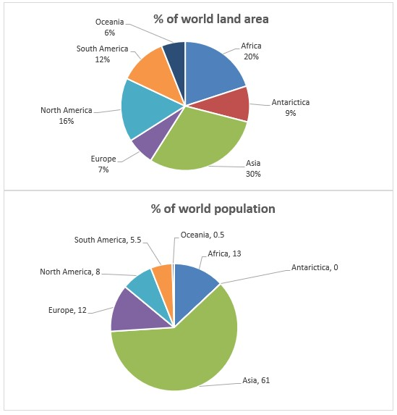

The pie chart depicts distribution of area and population of the world among seven continents.

Overall, Asia consist of the maximum percentage of world land area also, the more than half of population of the world belong it. In addition, Antarictica is the emptiest continent and Asia is the most congested area of land.

Looking more closely at the pie chart, we can see that more than 60% of world population lives in Asia, it just has less than one third of world land area (30%). While Antarictica include 9 percentage of world land area but has not any inhabitant.

According to the pie chart, Africa comprise 20 percentage of world land area and 13 percentage of world population. Furthermore, Oceania 6 percentage of world land area which it`s population tends to zero (0.5%). South American and North American consist of 12 and 16 percentage of world land respectively which is greater than percentage of world population. By contrast, Europe include 7 percentage of world land area which is less than percentage of world population.

Words: 175 time: 30 minute