*The pie charts below show the area and current population of the seven continents as a percentage of the total. Summaries the information by selecting and reporting the main features, and make comparisons where relevant.*

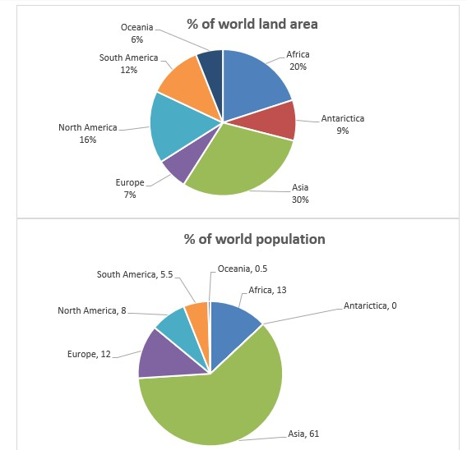

The given pie charts illustrate the current proportion of the population of seven continents and the percentage of area of the world belonging to each continent.

Overall, Asia is the most congested continent in the world which dedicated the maximum percentage of the world land to itself, while Antarctica is the emptiest one in the world.

Although more than half of the world population (60%) live in Asia, it just contains less than one third (30%) of the world land. Europe is another continent which has more population than its area. Only 7% of all world area belongs to this continent, however, it includes 12 percent of the world population. For other continents, the percentage of world land is greater than their population.

Oceania by having the minimum percent of world area is the smallest continent which includes less than 10 percent (6%) of the world population. South America and North America have 12% and 16% of the world land respectively, and the proportion of population is half of their area. Africa is the second populated continent in the world with 13%, and the second largest continent in the world with less than a fifth (20%) percentage of the world area.