The chart below gives data about the percentages of Internet users, categorized by age groups. Summarize the information by selecting and reporting the main features, and make comparisons where relevant.
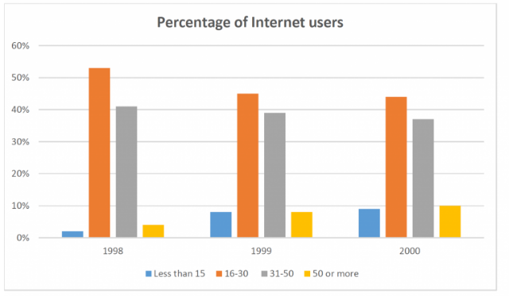
The graph outlines changes in the percentage of internet users based on their age groups between 1998 to 2000.
It is clear that proportion of internet users for people between 16 to 30 years old was significantly higher than other age groups, and internet users' ratio from younger and aged people was the lowest.
In 1998, more than of 50% of internet users related to young people in range of 16 to 30. In the next two years the using of the internet for this age group stayed the highest among other groups, however experienced a steadily reduction during these years. The figures dropped from nearly 50% in the first of period to just above 40% in the last year, 2000. Internet users between 31 to 50 were the highest group after young peoples (16-30), however the percentage of users did not decrease dramatically, they fell slightly from about 40% in 1998 to nearly 37% in 2000.
The youngest age group less than 15 and oldest (50 or more) had upward trend in using the internet. In 1998 about 2% od children used the internet, this figure raised to 8% in 1999, and it continued to increase to just under 10 percent in 2000. There was similar increase for old users, rising from about 4% to nearly 10% in 2000.
Elham Mirzavand.

