**Academic Writing task 1**

You should spend about 20 minutes on this task.

**The chart below gives data about the percentages of Internet users, categorized by age groups.** Summarize the information by selecting and reporting the main features, and make comparisons where relevant.

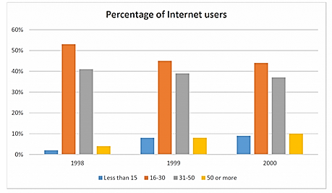

The bar chart illustrates some information about the distribution of internet users of different age ranges during a three-year period spanning from 1998 to 2000.

It is clear that the young people with the age of 16 to 30 years old were the main internet users all over the shown period while the number of individuals less than 15 years old was lowest.

In 1998, people between 16 to 30 years old accounted for more than half of users while over the following years the number of them dropped off slightly to 45%; however, they were still the biggest group of internet users. The second biggest group of users were in the range of 31 to 50 years old. The number of this group was about 40% in 1998, and then over the next years, the figures slightly decreased and finally reached just over 35% in 2000.

Lowes percentage of internet users belonged to children and older adults. In 1998, the number of children was nearly 2%, and it continued to increase by 8% in 2000. A similar trend was observed for old users, ranging from just under 5% in 1998 and 10% in 2000.