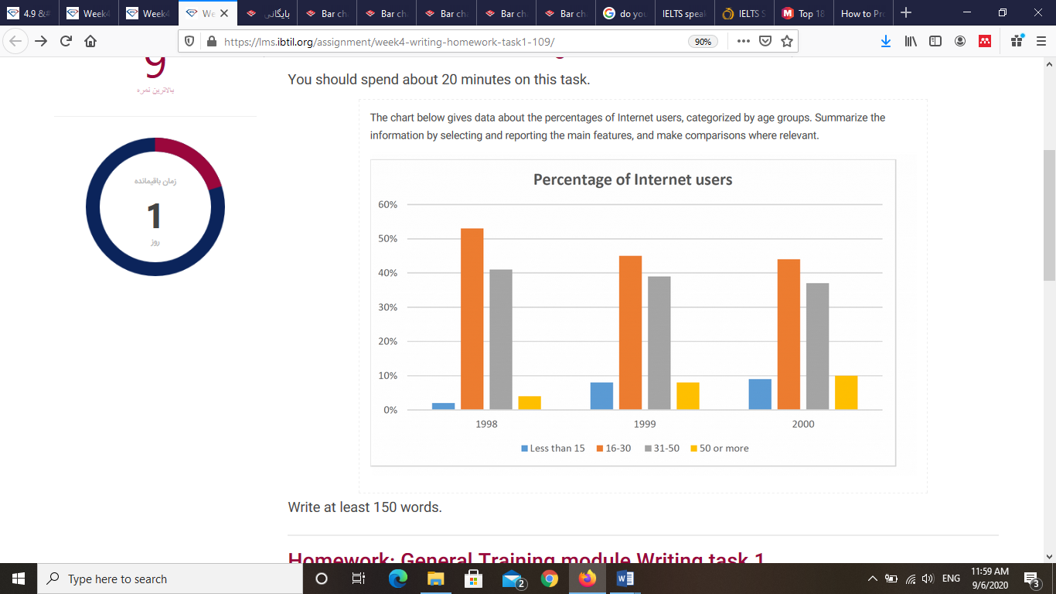The chart below gives data about the percentages of Internet users, categorized by age groups. Summarize the information by selecting and reporting the main features, and make comparisons where relevant

Write at least 150 words.

The bar graph compares four different age groups in term of using internet and illustrates how these trends changed over a period of two years.

It is clear that the proportion of people who use internet between age 16 and 30 or 31 and 50 was significantly larger than users under 15 or over 50 during these years. While internet users of two groups of 16 to 30 and 31 to 50 dropped slightly, two other age groups had a gradual increase.

in 1998, approximately 53% of internet users belonged to group of 16 to 30. Next year it declined about 10% and this followed by a slight drop to around 43% by 2000. Similarly, there is a decreasing trend for group of 31 to 50 years old which it decreased from just above 40% in 1998 to around 37% in 2000.

Furthermore, two other groups had lower proportions with approximately 2 and 4 percent for under 15 and over 50 age group respectively in first year and these increased steadily over two years to just about 9 and 10 percent in 2000.