The graph below shows the proportion of four different materials that were recycled from 1982 to 2010 in a particular country. Summarise the information by selecting and reporting the main features, and make comparisons where relevant.
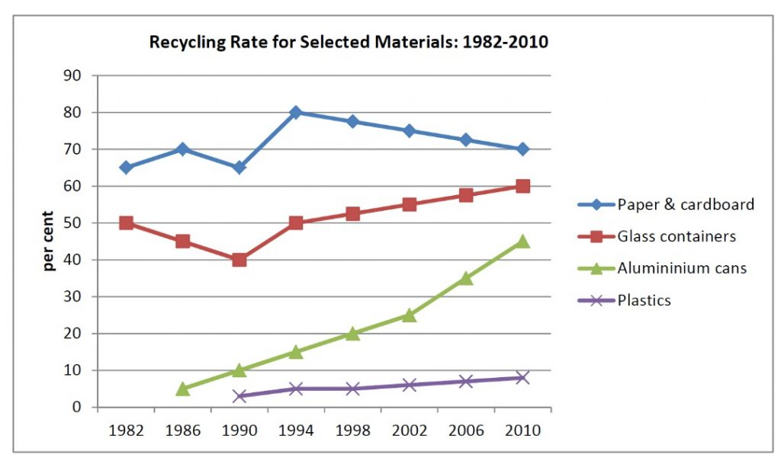
The line graph gives information about recycling rate for four selected materials from 1982 to 2010 in a special country. It is clear that paper & cardboards had the biggest proportion of recycling rate. On the other hand, the lowest share was concerned to plastics.
As can be seen from the graph, the highest rate of recycling belonged to paper & cardboards between 1994 and 1998 that picked at 80 percent. This amount gradually reduced to 70 percent by 2010. There was a moderate growth for glass from 1994 to 2010. Also, it had a valley at 40 percent in 1990.
The recycling rate of aluminum cans had significant climb from nearly less than 10 percent to more than 40 percent between 1986 and 2010. It had the biggest changes among these categories. The plastic recycling rate nearly remained steady and had slight increase from 1994 to 2010.

