You should spend about 20 minutes on this task.

The diagram below shows how leather goods are produced.

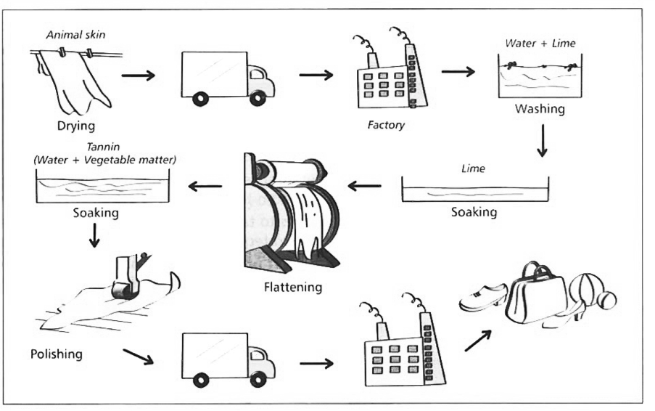

Write at least 150 words.

The flow chart illustrates the process of that is used to produce leather products.it is clear that there are ten stages in the process, beginning with the drying the animal skins and culminating in leather goods.

At the first stage of the process, skin of animals is dried by sun. These dried skins are then transported to a factory where the next five stages are taken in. First of all dried skins are washed with a mixture of water and lime. Second, they are soaked with lime for a while. The third step is to flatten these skins with special machines. Next, flattening skins are soaked again but this time in a mixture named tannin which includes water and vegetable matter.

Fifth stage in the first factory involve polishing. Wet skins are polished due to improve their surface quality, then they are transported to the final factory. Finally, skins are transformed to the end product which is leather goods.