The graph below shows the proportion of four different materials that were recycled from 1982 to 2010 in a particular country. Summarise the information by selecting and reporting the main features, and make comparisons where relevant.

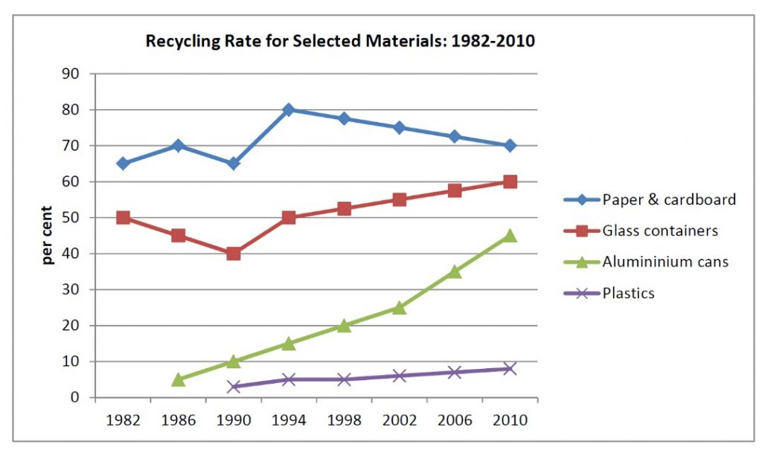

The line graph compares the percentage of four different materials (paper and cardboard, glass containers, aluminium cans and plastics) that were recycled in one country between 1982 and 2010.

It is clear that paper and cardboard were the most recycled materials although the trend was downward for these materials while others experienced an upward trend.

A more detailed look at the graph reveals that in 1982, about 65% of paper and cardboard was recycled. This figure fluctuated before rising to reach a peak 80% in 1994., however,after that it decreased steadily until 70% in 2010. In 1982, half of all glass containers were recycled; after that it fell to a 40% in 1990, the glass recycling rate gradually increased to 60% by 2010.

Aluminum cans were first recycled in 1986, starting at about 5%, but this figure rose dramatically to a peak of 45% over 25 years . by contrast, Plastic was the least recycled material. The recycling of plastic started around 1990. However, there was a small increase in the amount of plastic recycled over 20 years*.*