The plans below show a public park when it first opened in 1920 and the same park today.
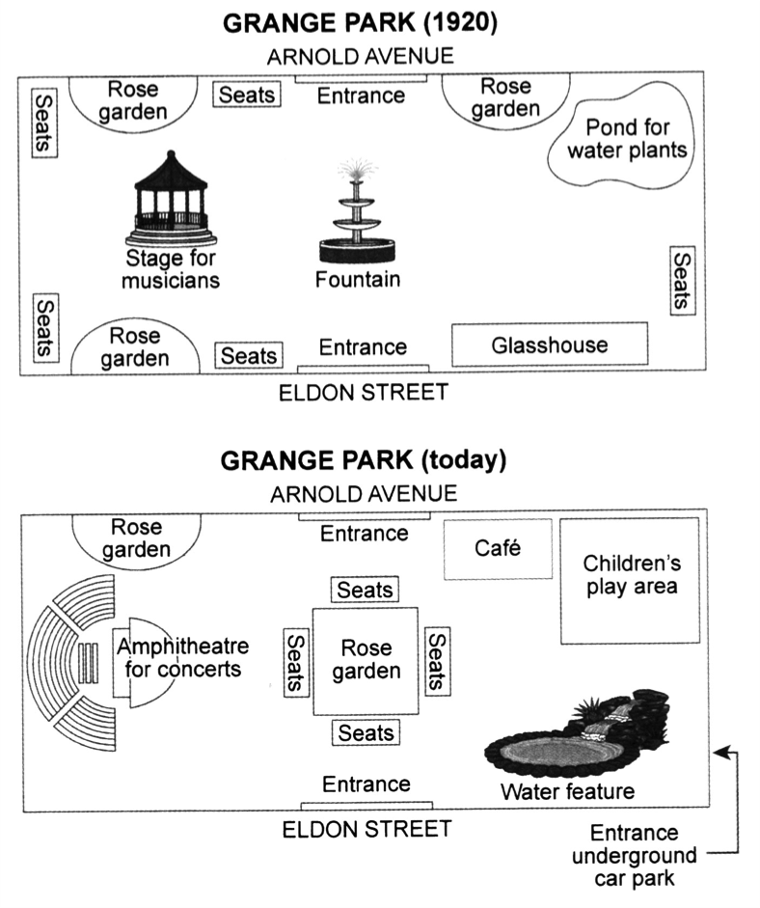

The given maps illustrate information about changes in the Grange Park since 1920 to nowadays.
Overall, it is clear that there have been several changes, the Fountain situated in the middle park and the Stage for musicians located in the left of park are removed. While, the new Water feature was builded in the right of the park
A more detailed look at the map reveals that Seats and Rose Garden were situated in different places, but these days, all of them, except the northwest rose garden, are locating in the center of the park, and became more beautiful together.
In addition, the Musicians stage has been replaced with the Amphitheatre for concerts and the Pond for water plants was taken over the Children’s play area. Lastly, the glass house removed, the new entrance for car parking has been constructed underground. The only things which were not changed during the time, two entrances which are situated in top and bottom sides of the park near to the central rose garden.

