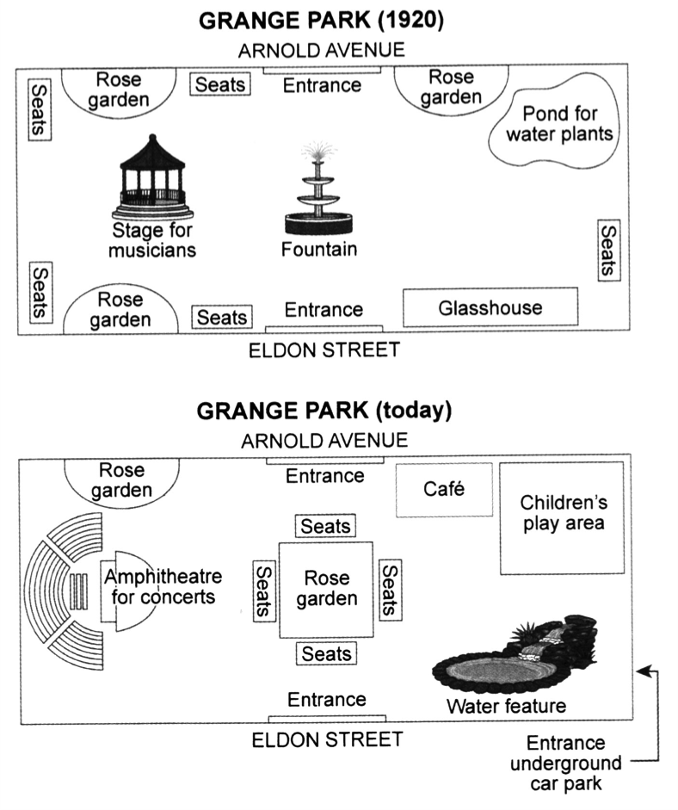
Q: The plans below show a public park when it first opened in 1920 and the same park today.
The plans explain the all structural changes that were made to the Grange Park from 1920 till now.
It is noticeable that three main modifications were made to the park. These involved the Fountain replaced with the Rose garden in the middle of park, and the Stage for musicians completely rebuilt into the Amphitheater for concert in the left margin of the park. Furthermore, the new Water feature was designed in the right corner of the park.
Looking at the changes in more detail, we can see that the four out of the five seats, which was around the park, were relocated to the center on the Rose garden side. The underground car park was another considerable change of the park which is at the southwestern corner of the park. Moreover, the Pond for water plants was taken over the Children’s play area. The glasshouse is not existed no longer. The location of the Café is also marked in place of the Rose garden which was on the side of the Children’s play area.

