**Some universities offer online courses as an alternative to classes delivered on campus. Do you think this is a positive or negative development?**

It is true that traditional learning has replaced by online course recently. There are several reasons which I consider, this is a positive trend.

In recent years most of the universities around the world have trended towards the online classes for some reason. It seems to me that these reasons have far more benefit for universities and students. The average cost of utilities of the university will be reduced by more than half, which is economical for them. Because there is not any students or teachers to use campuses services while the university takes a tuition fee from each student. For example, they do not need to pay costly bills such as electricity or water Because, just staffs and managers are there, not anyone else.

I believe that students are allowed to study whenever and wherever they want and convenient. That means if they want to study, they can connect to the internet in travel or the end of the day. They not supposed to leave their city and rent a new apartment or dormitory near their campus. For instance, most of the youths will have to pay a lot of tuition for transportation, food and so on if they move out. Besides, when at least 10,000 students stay at home, wasting time in a traffic jam can be dramatically reduced especially in rush hours. Therefore, this method can decrease the cost of living noticeably.

In conclusion, I believe that online classes instead of classroom learning is significantly useful for both students and the university.

**The chart below gives data about the percentages of Internet users, categorized by age groups. Summarize the information by selecting and reporting the main features, and make comparisons where relevant.**

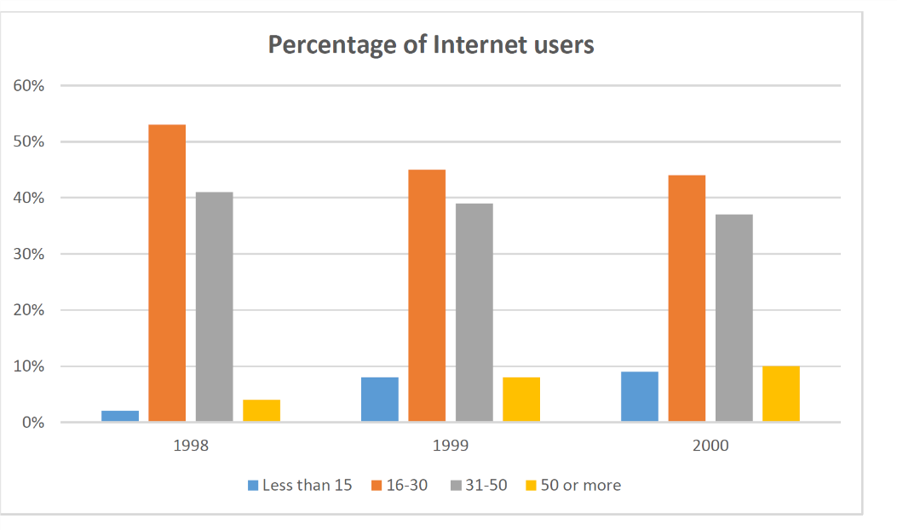

While the bar graph illustrates the percentage of Internet users by ages spanning from 1998 to 2000, it is clear that youths between 16-30 years old had the highest rate of users of the internet overall. The first group (less than 15), by contrast, had the lowest rate of internet users for 3 years.

People between 16 to 30 years, had the highest percentage of the net user from 1998 to 2000 as illustrated on the bar graph in 1998, reached a pick at about 52% then dropped slightly about 43%. By contrast, from 1998 to 2000 web surfers from the third group (31-50) has the highest rate after the first group with about 39% averagely.

According to both figures, percentage of Internet users from the first (less than 15) and fourth (50 or more) groups rose gradually from 1998 to 2000, then reached a pick at least 9 to 10 per cent respectively.