IELTS Course 104
Taught by Professor Bahram Modaberi
Week 7, Writing homework
Written by Siyamak Eslami
July 30, 2020

Academic Writing Task 1
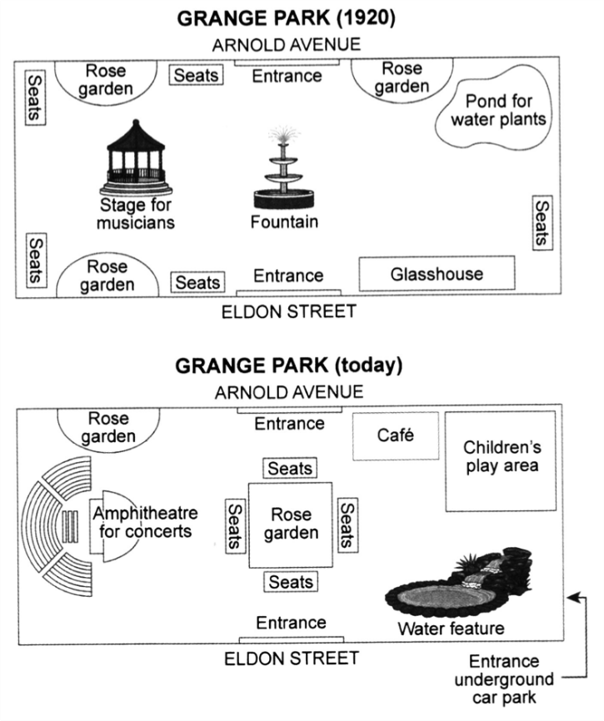

Comparing the map of the public park in 1920 with the map of today, it is concluded that many parts of the interior of the park have changed.

It can be seen that the rose garden in the southwestern part has been moved to the center of the park and the seats have been collected around the park and placed around the rose garden. In the past, the fountain was located in the center of the park, but now it does not exist.

A café replaces the rose garden in the northeast and a pond for water plants in the northeast corner has been removed. Also, instead of a glasshouse in the southeastern part, a water feature has been created. The location of the park entrances in the northern and southern parts has not changed, but an entrance underground car park has been created in the southeast corner.

Now there is a children’s play area that did not exist before, and instead of the stage for musicians, an amphitheater has been built. Previously, there were 3 rose gardens in the north and south of the park, but now there is only one rose garden in the park. (197 words)

General Writing Task 1
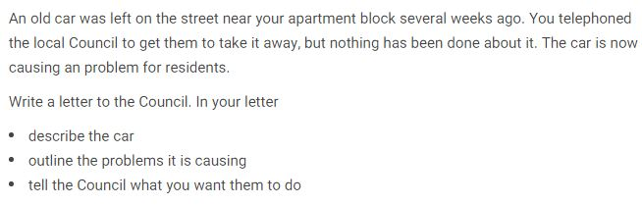
Dear Sir,
Following a previous phone call about moving an old car left on the street, unfortunately no action has been taken so far. The car is a 1960s black Ford and has been here for about a month. The license plate is from the state of Arkansas, which is 1000 miles away. The car windows are broken and the cats live inside.
Due to the large size of the car, during the busy hours of the day, it causes heavy traffic and the neighbors are upset about this. I also informed the police and they came here to investigate, but in the end, they said that since the car is not dangerous for people, you should wait for it to be moved by the car owner.
One of the neighbors suggested that we file a lawsuit, but we decided to pursue the matter in writing through the local council.
Please follow up to resolve this issue.
Sincerely,
Siyamak Eslami (160 words)

