The chart below gives data about the percentages of Internet users, categorized by age groups. Summarize the information by selecting and reporting the main features, and make comparisons where relevant.

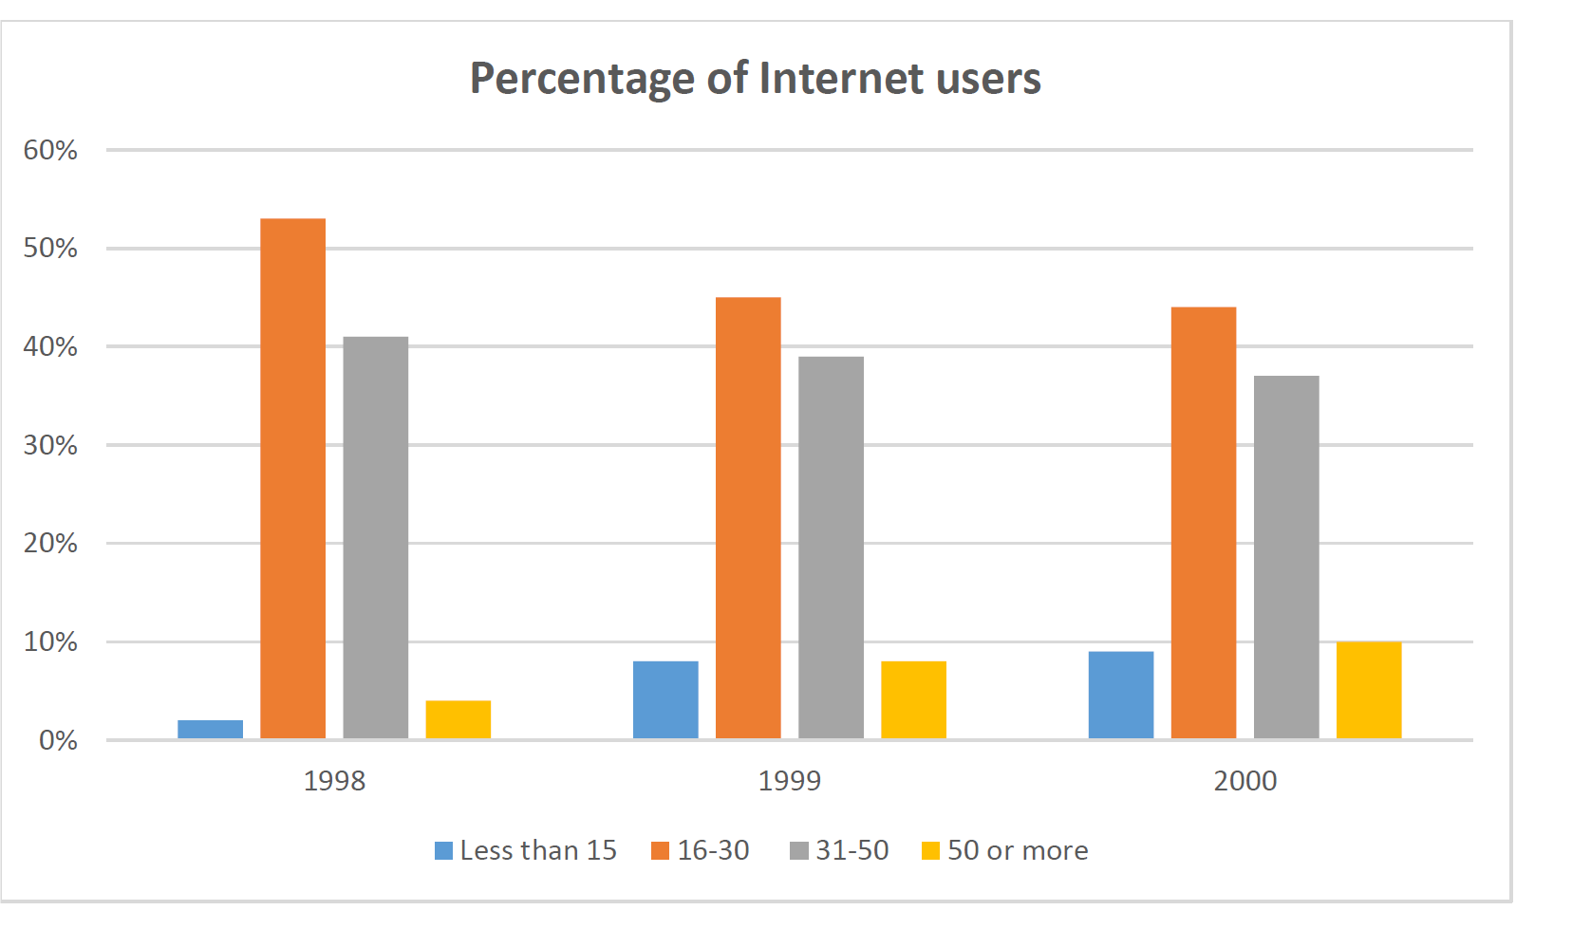

The bar chart provides some information about the proportion of people who used internet in four different age groups between1998 to 2000.

While the figure had several trends, it is clear that the amount of 16-30 age group had the most access to the web over the period. Instead the people aged less than 15, had the lowest percentage of web users overall.

According to the chart, the figure of people in the age ranges of 16-30 and 31-50 experienced slight decline in internet usage. The amount of 16-30 age group decreased from just over 50% to under 45%. Moreover, the proportion aged 31-50 fell about 5% during this time.

Additionally, there is a steady growth in use of internet for people aged less than 15 and 50 or more. The people who are less than 15, had the least access to internet in 1998. Its proportion reached to 10% in 2000. Besides the age group of 50 or more rose almost 5% since 1998 to 2000.