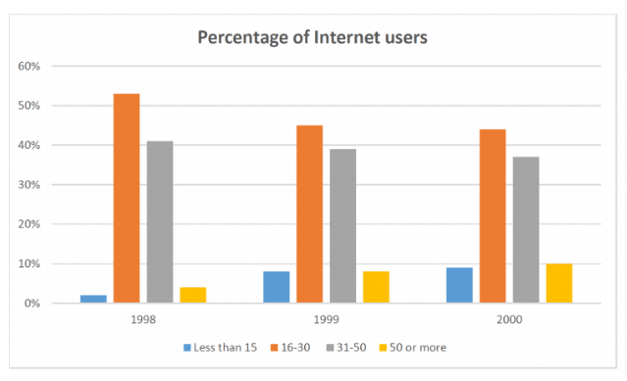

The bar chart compares the percentage of Internet users in three years, categorized in 3 groups by age.

Overall, the percentage of internet users aged 16-30 were highest in all measured years. In addition, figures for all age groups increased over the period. People under 15 year old, on the other hand, had the lowest percentage for the majority of the period.

The percentages of those aged 16-30 and 31-50 have formed the biggest amount of internet users whole three years shown in graph, moreover, both of them followed similar trends over the measured period. There were significant decreases in these figures beginning at over 50% and 40% in 1998, and ending at around 45% and fewer than 40%, in 2000.

In contrast to the figures for the other two ages, the amount of users rose steadily between 1998 and 2000, reaching a peak of about 10% at the end of the end of the period.