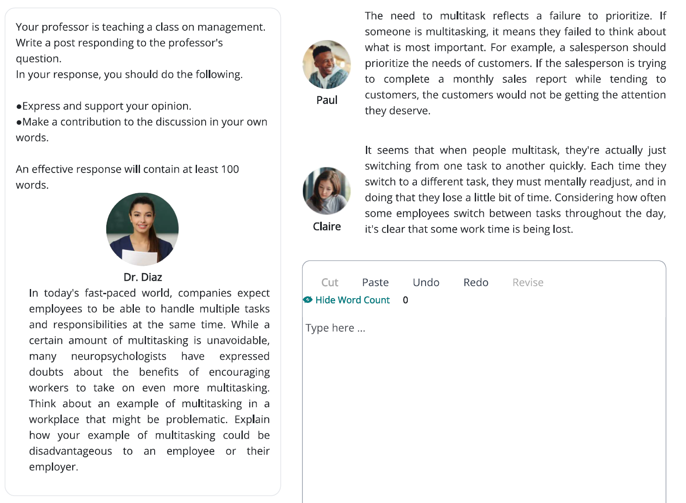
I believe that when workers multitask, they will not be able to concentrate on a specific task and this leads to a lack of quality in outcomes. As Claire mentioned, multitasking requires switching between different tasks, because people cannot do multiple tasks at the same time. Not only do workers lose time to mentally readjust, but they also lose concentration. In this situation, their productivity will be reduced and the tasks will not be accomplished effectively. The more irrelevant the tasks they switch between, the greater the loss of productivity. For instance, every time a software engineer switches between programming and writing documents, it takes a long time to adapt to the new task. So if he can write 100 lines of code with no bugs in one hour without switching, he will probably write just about 80 lines in the same amount of time with multiple bugs which are caused by lack of concentration. In short, multitasking reduces the productivity and concentration of workers.
165 words, 21 minutes
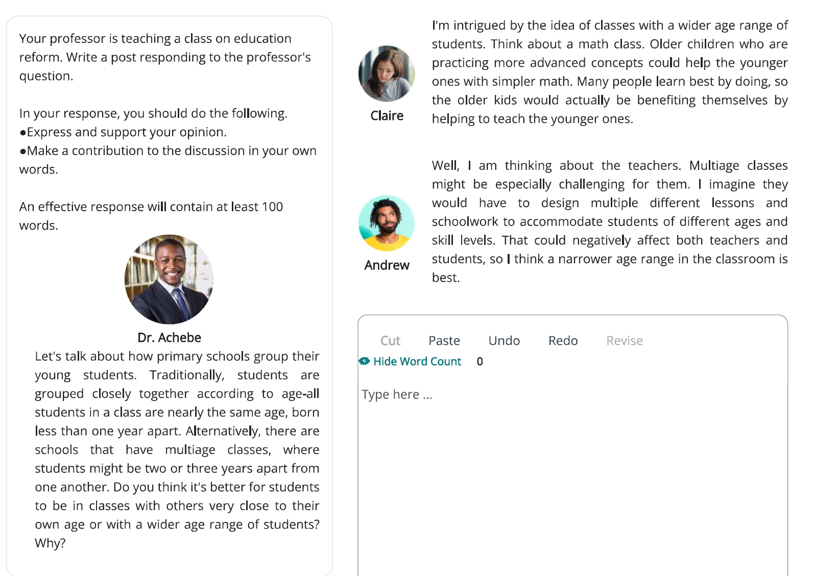
I go along with Andrew's idea that it is better for students to be in classes where all students are nearly the same age. Students of different ages have different requirements and mental abilities. So not only should they study different materials, but they also should be treated differently. In fact, older students should study more complex materials, because they have already learned simpler lessons. Covering this wide range of content puts a lot of pressure on teachers. Moreover, younger students should be treated more kindly. To put it differently, younger students are not completely independent from their parents, so teachers should bear this in mind and help them so that they get used to school. But teachers will not be able to manage these different manners in a class composed of students of different ages. In short, I believe that multiage classes are not a good design for schools.
150 words, 18 minutes

