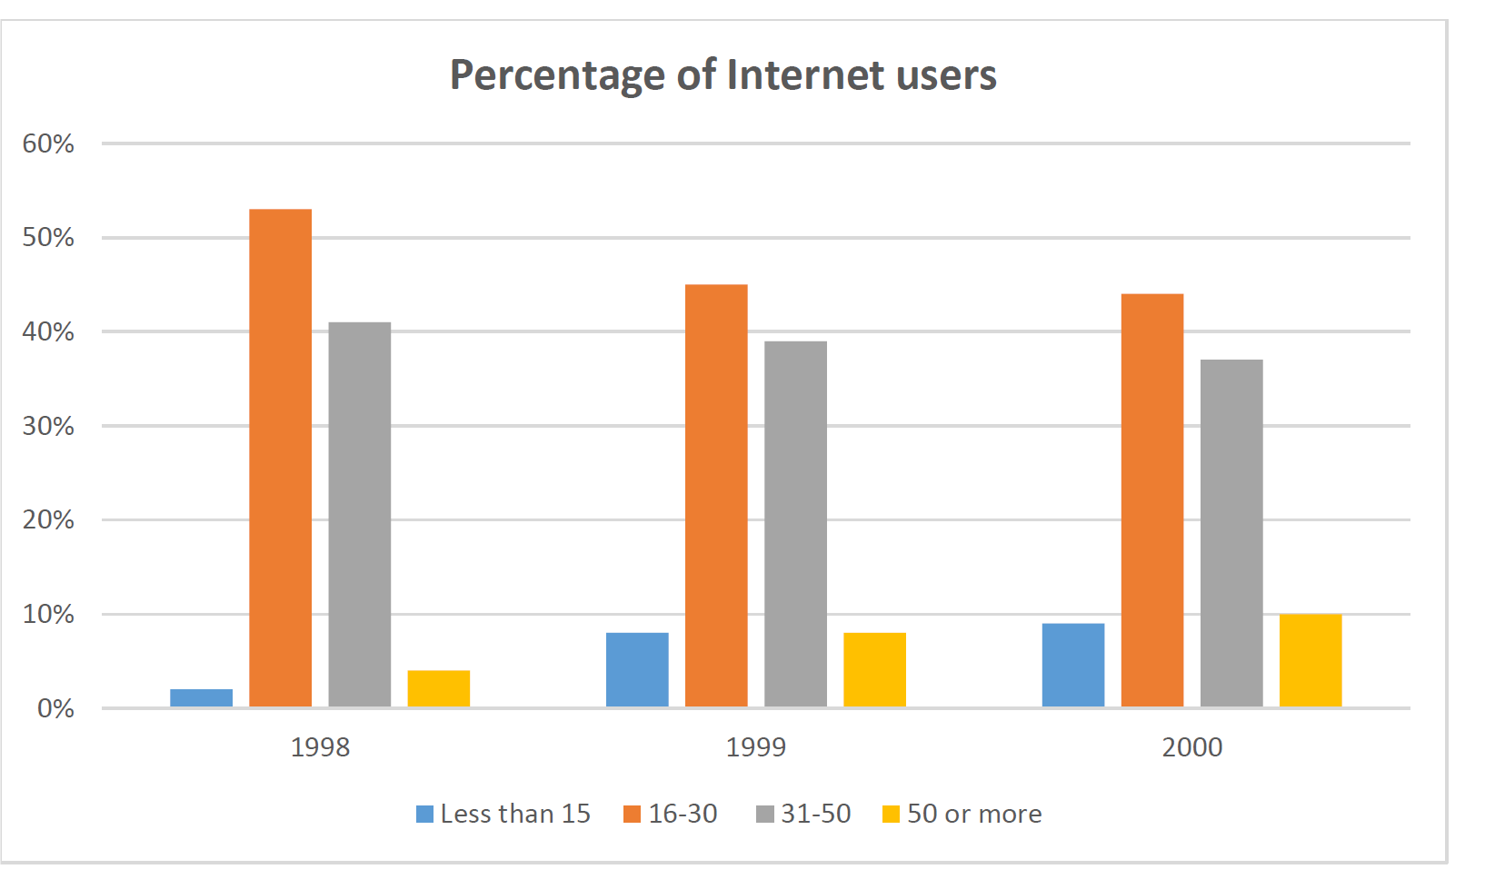**The chart below gives data about the percentages of Internet users, categorized by age groups. Summarize the information by selecting and reporting the main features, and make comparisons where relevant.**

The bar chart compares internet usage by people with different age groups between 1998 and 2000.

It is clear that the primary users of the internet were young adults between 16 and 30 years old. By contrast, children and older people recorded by far the lowest figures.

In 1998 The biggest group of users was aged between 16 and 30. They made up 52% in 1998 and then falling slightly to 45% in 2000. The second biggest group is aged between 31 to 50. The internet used by this specific group showed similar trends for the projected periods; 41%, 39%, and 37% in three years. So, this number is dropping steadily.

In 1999, the number of children online quadrupled from 2% to 8%, and it continued to increase in 2000. There were similar increases for older users, rising from 4% in 1998 to 10% in 2000. while adults between 16 and 50 still represent the great majority of Internet users, their share is declining as more children, and older users join the web.