The table below shows the numbers of visitors to Ashdown Museum during the year before and the year after it was refurbished. The charts show the result of surveys asking visitors how satisfied they were with their visit, during the same two periods.

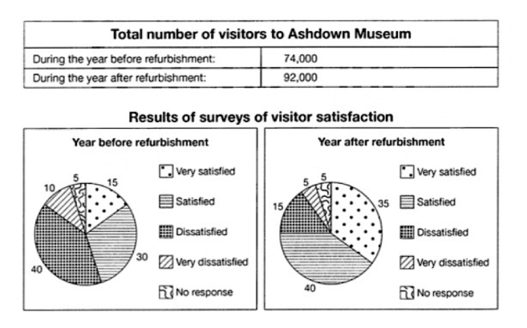

The table illustrates the total number of visitors to Ashdown Museum in the year before and after it was refurbished. The pie charts indicate the percentage of visitors satisfaction during the same two periods.

Overall, it is clear that both the number of visitors and the amount of satisfaction increased during the year after refurbishment.

The table shows the museum attracted 74000 visitors before refurbishment which rose to 92000 visitors in the year after refurbishment.

Regarding to visitors’ satisfaction, the proportion of very satisfied increased from 15% before refurbishment to 35% after refurbishment. The percentage of satisfied almost remained stable at 30% before refurbishment to 40% after. On the other hand, dissatisfaction of visitors decreases significantly, and proportion of dissatisfied fell from 40% to 15%, and very dissatisfied visitors decreased slightly from 10% to 5%. Moreover, the proportion of people who not responded was about 5% and this amount remained without change even in after refurbishment.