The chart below gives data about the percentages of Internet users, categorized by age groups. Summarize the information by selecting and reporting the main features, and make comparisons where relevant.

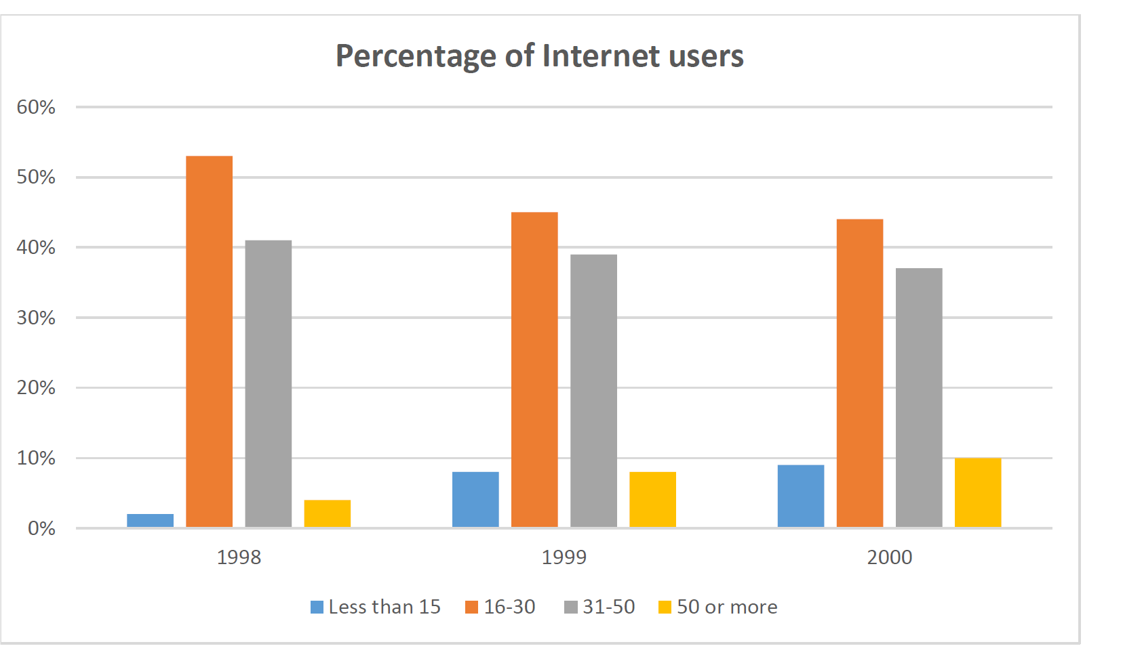

The chart above illustrates the percentages of people who use the Internet, based on their age (Less than 15, 16-30, 31-50, and 50 or more) in three successive years (1998, 1999 and 2000).

Overall, people under 15 and above 50 years old, use the Internet considerably less than people between 16 to 50 in the period given. The majority of Internet users are the young and the middle age people.

On the one hand, the percentages of users both less than 15 and 50 or more have slightly increased (from around 2% to about 9% and form under 5% to 10% respectively). On the other hand, Internet usage for the remaining groups (16-30 and 31-50) has minimally declined (from about 53% to about 45%, and from over 40% to about 48%, respectively).

In addition, the least and most percentages of internet users exist in 1998: 15year-olds and under with about 2% and age group of 16-30 with almost 53%; furthermore, in spite of these changes, they have maintained as the least and most users in 1999 and 2000 yet (by around 8% and near 45% in 1999 and under 10% and almost 44% in 2000).