You should spend about 20 minutes on this task.

The chart below gives data about the percentages of Internet users, categorized by age groups. Summarize the information by selecting and reporting the main features, and make comparisons where relevant.

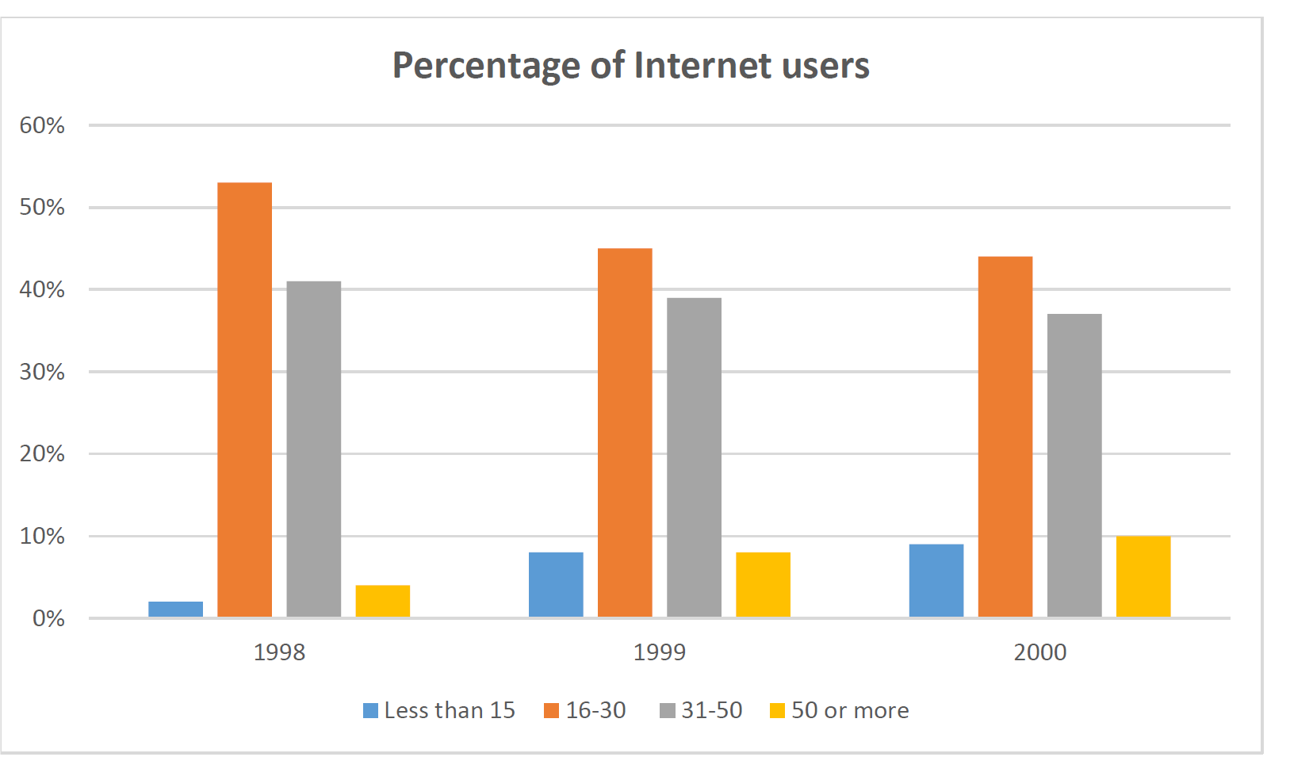

Write at least 150 words.

The bar chart provides information about the rate of people who use the Internet in 4 groups ages including; less than 15, between 16 and 30, between 31 and 50 and more than 50 between 1998 and 2000.

Overall, group16- 30 and group less than 15 accounted for the highest and lowest number of Internet users, respectively, in 2 years. The trend of the 15-30 was downward while in less than 15,the trend was upward at this point in time.

In 1998 had a maximum rate of user internet in both groups 16-13 and 31-50 about 55% and 40% respectively. And, this year other groups had a minimum rate but percentages of these groups increased and reached approximately 10 % to end of the period.

on the other hand, during 1998 to 2000, the rate of changes was about 10% in 16-30 group whereas, in the group 31-50, the trend was steady and thr rate of changes was about 4-5,  such as other groups.