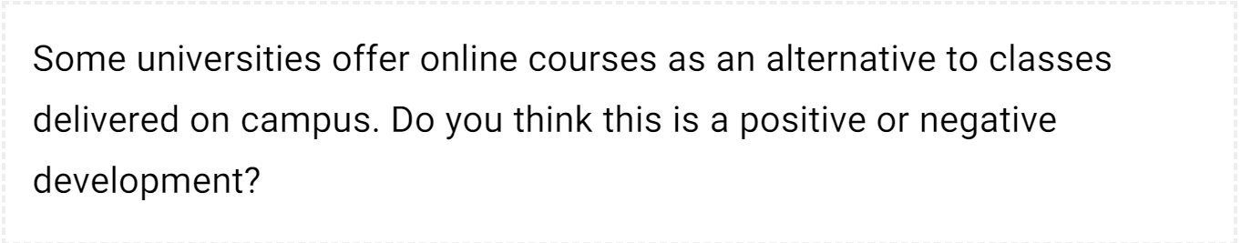

It is common that educational institutions are taking online courses. In my opinion, this trend could have both positive and negative consequences in equal measure.

The first advantage of online classes is the ability to take distance education from many locations. Location is not determining factor in a student’s ability to take a course. It identifies a positive aspect of place flexibility which offers students to take modules from other institutions. The next advantage is self-paced feature of online education. Students have this ability to work at his or her best speed. In addition students have the flexibility to review lessons as many times as is needed.

However, the main drawback of the trend towards online courses is that social isolation. Both students and instructors can become isolated. Students are cut off from their instructor and from other students, While students have more interactions and communications in classes that are delivered on campus. On the other hand, online classes rely on student’s self-motivation. Each student must determine when and how long to study. For example students in the controlled environment of a classroom are not usually disturbed by external distractions. Whereas online-class students experience interruptions such as telephone calls, children or pets entering the room while they are learning. Finally, it is virtually impossible for online-module instructor to know if students are actually online and paying attention to the class.

In conclusion, while I recognize the possible downsides of online learning modules, I consider it to be a positive development overall.