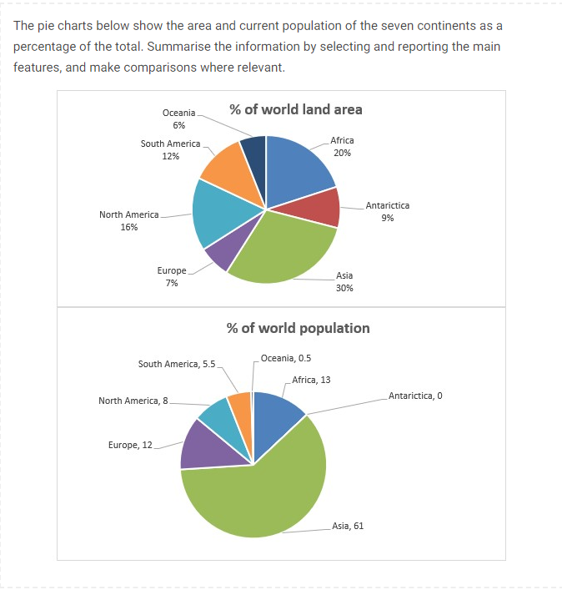

The charts, reports the percentage of the total for area and current population of world’s continents. They showed that Asia dedicated the most of the world’s area and population to itself. Also the graphs revealed that while a notable area of the world is devoted to Antarctica, its population was neglectable in comparison to the other continents.

Based on these figures, the occupied area by continents in descending order was: Asia (30%), Africa (20%), North America (16%), South America (12%), Europe (7%), Antarctica (9%), and Oceania (6%). However the portion of population who lived in these continents did not follow this order. For example, Antarctica and Oceania, in total, had 15% of the world’s area, while their total population was only 0.5% of the world.

Also, the ratio of the population to the used area showed that Asia and Europe had the highest ratio about 2, while Antarctica and Oceania had the lowest amount near zero. Also, this ratio for South and North America and Africa was about 0.5 and was almost the same for these continents.