The graph below shows the proportion of four different materials that were recycled from 1982 to 2010 in a particular country. Summarise the information by selecting and reporting the main features, and make comparisons where relevant.

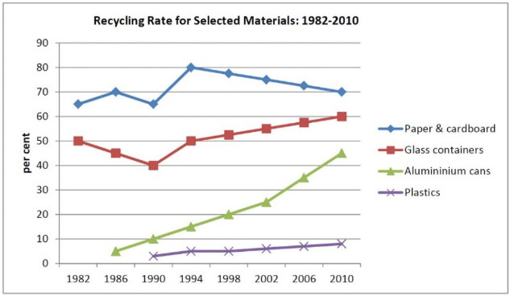

The figure, depicts the percentage of recycling rates of four different over a period of 28 years, from 1982 to 2010.

Based on this graph, it is clear that, in the entire period, paper and cardboard have the highest recycling rate, while, plastics by far, dedicates the lowest recycling rate to itself.

In 1982, the paper and cardboard was the most significant recycled materials, with recycling rate of about 65 percent. This rate rises to 80 percent in 1994, but falls to 70 percent with a constant slope for the remaining of the period. Recycling rate of glass containers have different behavior. It starts with 50 percent in 1982, then declines to 40 percent in 1990. After that, this rate increased monotonically to 60 percent in 2010.

In 1986 and 1990, reports of recycling of alumininium cans and plastics are revealed respectively. Surprisingly, the recycling rate of alumininium cans grows significantly. It starts with less than 5 percent in 1986 and reaches to 10 times of its start rate in 2010. For plastics, however, this rate keeps its lowest rank and remains just below 10 percent for the entire period.