The plans below show a public park when it first opened in 1920 and the same park today.

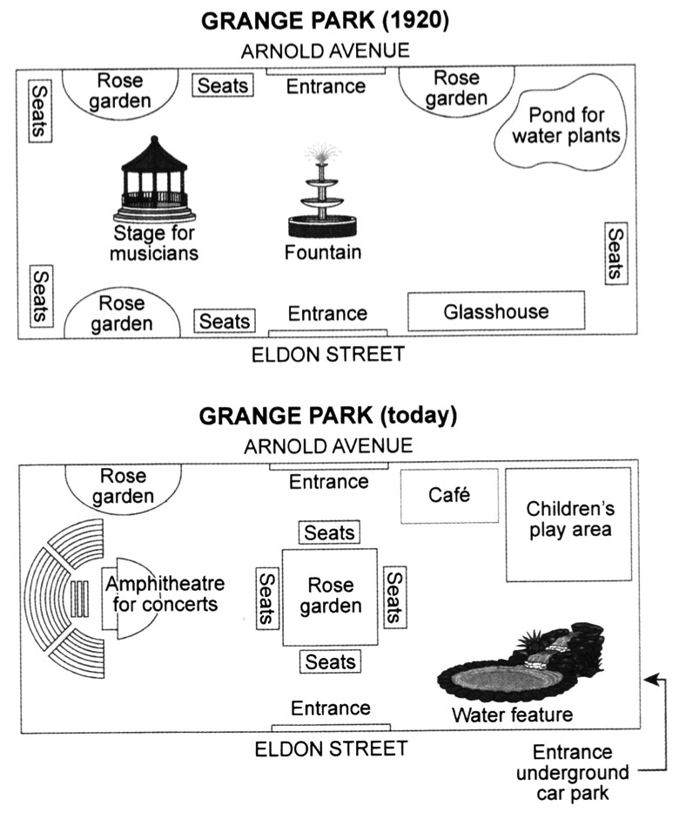

The two maps illustrate a number of changes which took place in a public park between 1920 and today.

From the maps, it is clear that the most noticeable changes that occurred in the park were water feature and amphitheater for concerts. Additionally, the fountain and stage for musicians had completely disappeared in second map.

In the past, there was rose garden in the top right-hand next to the entrance, whereas now café is there. The pond for water plants now contains children’s play area, and it increased in size. In 1920 fountain was in the middle of the park but it demolished, and now a square shape rose garden is replaced.

In both maps just two entrances and one rose garden that is in the top left-hand have not changed. In second map, we can see that the entrance underground car park is built in the bottom right-hand corner of the park.