The pie charts below show the area and current population of the seven continents as a percentage of the total. Summarise the information by selecting and reporting the main features, and make comparisons where relevant

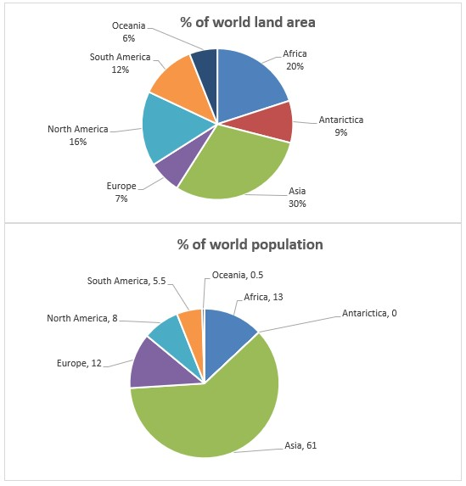

The pie charts compare seven continents in terms of the proportion of land area and population.

It is clear that while Asia has the highest figure in both charts, the reverse is true for Oceania land area and the population of Australia.

In terms of land area, half of all the world land area is in Asia and Africa, at 30% and 20% respectively. By contrast, only 7 percent of land is in Europe and 9% in Antarctica. The percentage of area in South America is exactly double that of Oceania. Additionally, North America has more land area in comparison with South America.

Regarding the second chart, Asia not only has the most land area but also contains the highest population, more than half of the world population. After Asia, Africa has the largest quantities at 13%. Although Europe has low area, it has 12% world population. Antarctica is uninhabitable and nobody lives there. Furthermore, the population of Oceania made up only negligible figure, under one percent.