The pie charts below show the area and current population of the seven continents as a percentage of the total.

Summarise the information by selecting and reporting the main features, and make comparisons where relevant.

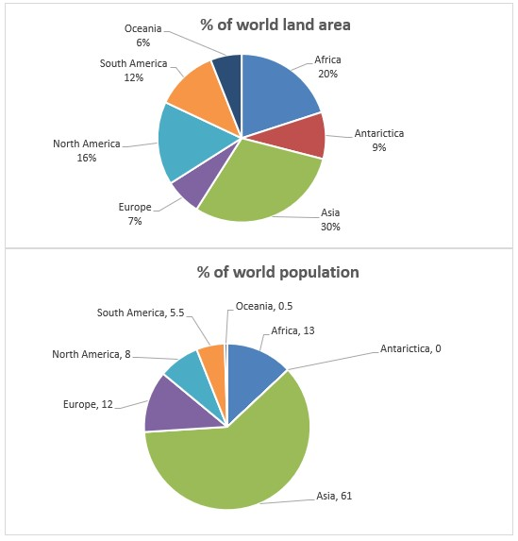

Write at least 150 words.

The pie charts compare the percentage of population and land area in seven different continents of the world.

It is clear that the largest proportion of land area and world population is belonged to Asia; while Oceania and Antarctica sectors have by far the smallest world land area and world population, respectively.

A more detailed look at the pie charts reveal that Asia occupies 30% of total land area; while Africa is the second-largest continent in the world with 20% of land area, followed by north and south America where 16% and 12% of land area are located, respectively. However, 9% of land area can be seen in Antarctica, which is nearly the same as Europe (7%). Finally, Oceania has the smallest sector, approximately 6%.

In terms of world population, 61% of people live in Asia followed by Africa and Europe with 13 and 12 population percentage, as second and third largest population sector, respectively. The rest of people live in north and south America, and the percentage of people in Oceania is insignificant; while, there is not any suitable condition for living in Antarctica, and nobody lives there. (189 words)