**You should spend about 20 minutes on this task.**

**The graph below shows the proportion of four different materials that were recycled from 1982 to 2010 in a particular country. Summarise the information by selecting and reporting the main features, and make comparisons where relevant.**

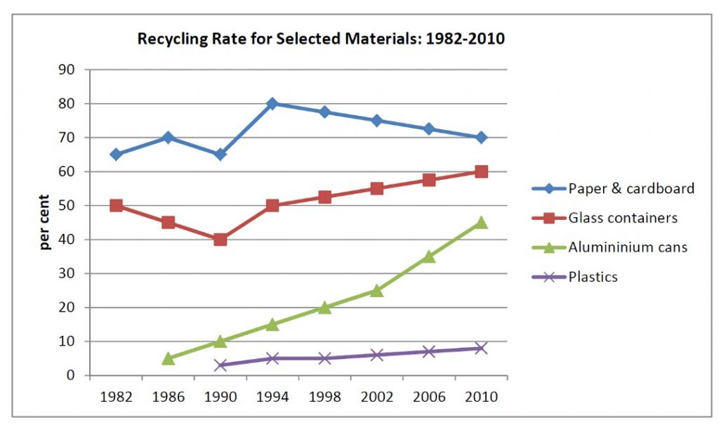

**Write at least 150 words.**

The line graph illustrates the comparison amount of recycling for some materials, such as paper & cardboard, glass containers, aluminum cans and plastics, between 1982 and 2010.

It seems, paper & cardboard and glass containers were the most sections. Aluminum cans surged by passing the time; nevertheless, the recycling of plastics stabilized at the lowest part.

Over the period 1982 to 1990, the output of paper & cardboard rosed and felled within a narrow range. glass container experienced a steady decrease, and both of them reached a plateau in 1990, but the recycling of plastics was ignored in this period of time. However, aluminum cans recycling started in 1986.

From the 1990 onward, after increasing in paper & cardboard and reaching at the peak, a gradual decrease was observed in the whole 16 following years. However, in this period of time, there was an up-ward trend in both aluminum cans and glass container, and the increase in plastics was insignificant. (160 word)