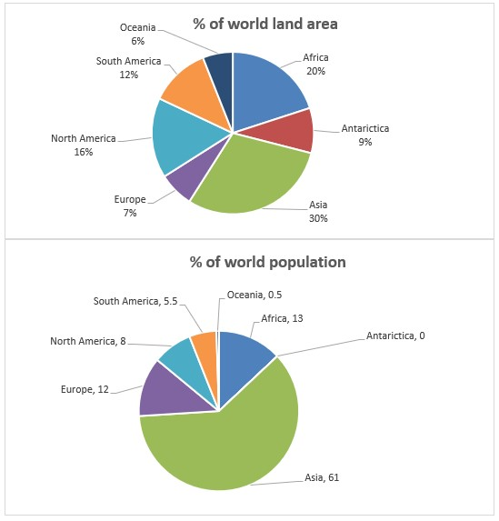

The pie charts aim to give information and compare the percentage of the world land area and current population in seven continents.

It is noticeable that, Asia has the most percent in both world land area and world population with 30% and 61% respectively. In contrast, Oceania has the lowest percent in the world area, (6 percent) and also the lowest percent in the world population. (0.5 percent). Looking more closely at the chart, Although Antarictica involves 9% of the world land area, it has no population in the world.

As we can see, it is clear that, after Asia, Africa with 13% and Europe with 12% have the most population in the world. In terms of land area, Africa with 20% and North America with 16% have the second and third levels in the world respectively.

According to the chart, Europe with 7% of the world land area, has 12% of the world population. While, North America with 16% of the world land area, has 8% of the world population.