**The pie charts below show the area and current population of the seven continents as a percentage of the total. Summarise the information by selecting and reporting the main features, and make comparisons where relevant.**

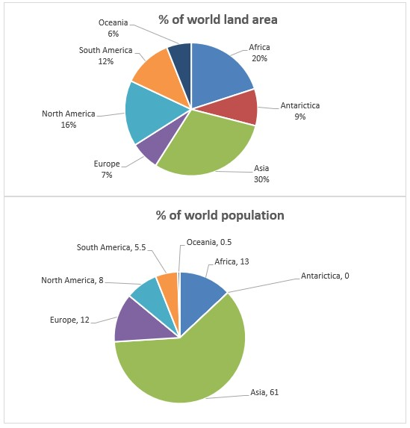

The pie charts illustrate area and current population of seven continents in the world as a percentage of the total.

It is clear that Asia represented the largest portion of both the land area and population in the world. Although Asia continent covered just 30% of the world surface area, 61% of global population lived in this area. Oceania, Europe and Antarctica were smallest sectors of the pie graph and they separately, had less than 10% of total world surfaces. Europe had global shared population of 12% meanwhile, it was just 0. 5% for Oceania and there was not any human in Antarctica continent.

The portion of global area that covered by the North and South America was 16% and 12% respectively. Although North America covered larger portion of area land than South America, it had smaller share population. In addition, all together, these two continents represented 28% of global surface portion while they made up just 13.5% of current world population as a percentage of the total.

Bahar raesi