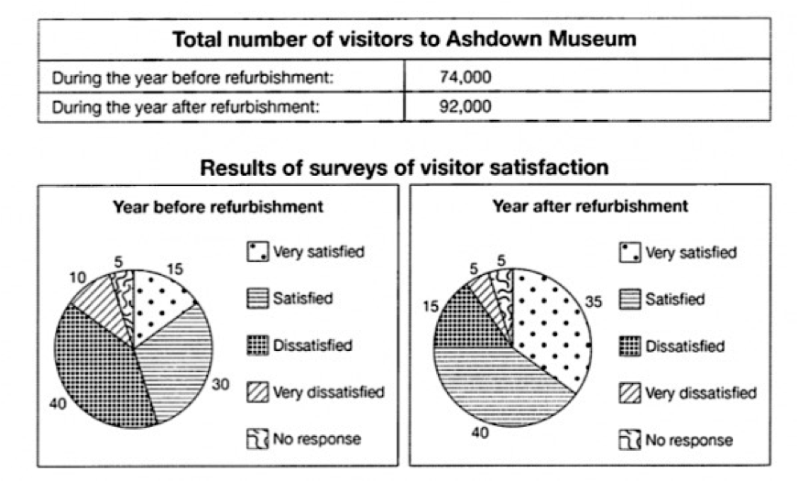

The table and pie charts illustrate the number of visitors and proportion of fulfilment of visitors respectively before and after renovation of Ashdown museum.

It is true that the number of visitors after renovation of museum rise also all range of satisfaction of visitors increase too.

Total number of visitors before renovation of museum were 74000 but we witness after renovation, the number of visitors are increased to 92000 over the year

According to the pie charts, 30% of people who visited before renovation of museum were satisfied and 40% of them were dissatisfied also 10% were dissatisfied too and just 15 % of them very satisfied that it shows the most of the visitors were dissatisfied in the year. While after renovation the highest figure is 40% that it belongs to people who are satisfied and dissatisfied figure is 15% which is almost half used to be also figure of very dissatisfied decrease to 5% and we see 5% in both pie charts that it belongs to people who not respond to this survey.