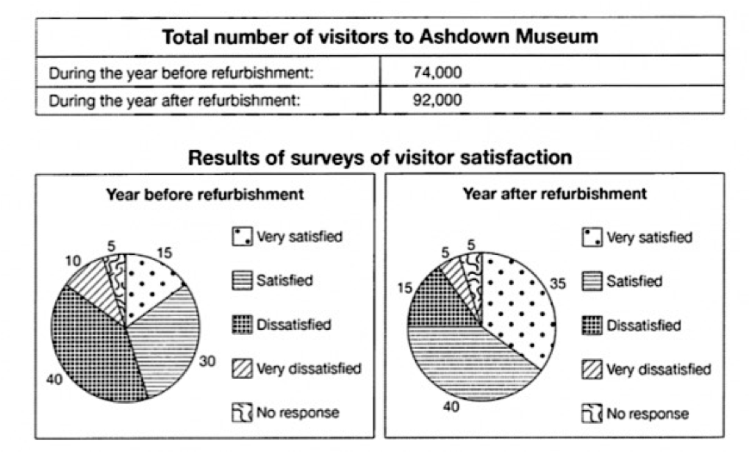The table below shows the numbers of visitors to Ashdown Museum during the year before and the year after it was refurbished. The charts show the result of surveys asking visitors how satisfied they were with their visit, during the same two periods.

The table and charts compare the entire of people who visited the Ashdown Museum and the outcome of questionnaire about the level of their satisfaction before and after renovation to the museum in terms of percentage over the same length of time.

It is clear that new appear of museum was remarkably effective in increasing visitors. As you can see overall people who visited the museum increased considerably. While, the majority of visitors were dissatisfied before revamping the museum, total number of dissatisfied sightseers to the museum reduced significantly.

During the year before renovation, total amount of visitors were 74,000 and according to the pie chart dissatisfied people were about 40%. 30% of individuals rated they are satisfied with their visit. Furthermore, close to 15% and 10% of sightseers answered that they were highly satisfied and extremely dissatisfied respectively.

In the same period after refurbishment, table reports Ashdown Museum total of visitors were 92,000. 40% of 92,000 sightseers were satisfied and 35% of them were extremely satisfied and dissatisfied and very dissatisfied answers included only 20% of people. Negligible group of people didn’t respond at all.