The table below shows the numbers of visitors to Ashdown Museum during the year before and the year after it was refurbished. The charts show the result of surveys asking visitors how satisfied they were with their visit, during the same two periods.

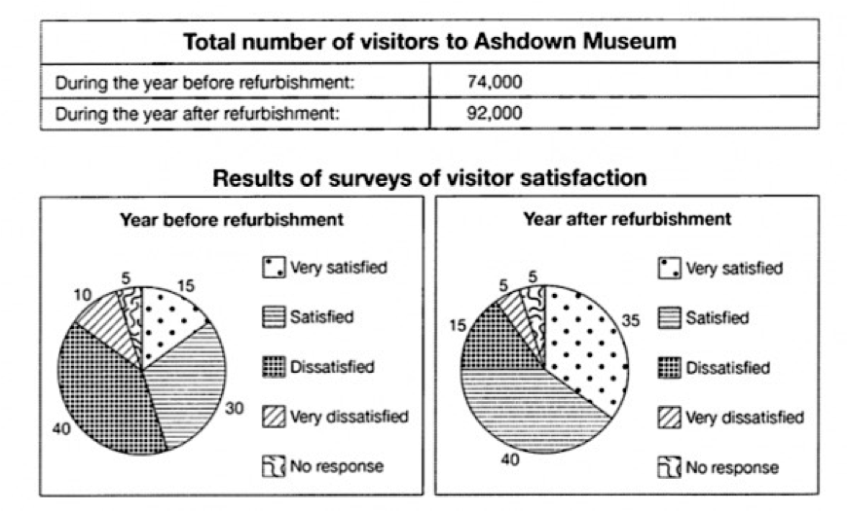

The table illustrates the number of annual visitors of Ashdown museum before and after it was refurnished, and the pie charts show the measure of satisfaction in visitors during the periods.

It is clear that, after museum was refurnished the number of visitors saw a significant growth during the period shown. Meanwhile, the survey demonstrate that people are more satisfied with new model of museum.

According to the table, annual visitors of museum before construction was 74000 while this measure rose to 92000 after remodeling the museum.

Regarding the pie charts, the percentage of satisfied people with museum services was 30 percent as well as this figure increased by 10 percent in the next period. On the other hand, 50 percent of the people who have answered the survey was either dissatisfied or very dissatisfied with museum while this proportion drop to almost one third in the second year. Before renovation 15 percent of people were very satisfied, however, this rate rose to 35 percent after refurnishing the museum. Unanswered surveys remain in the same amount of 5 percent in both years.