# Task1. The plans below show a public park when it first opened in 1920 and the same park today.

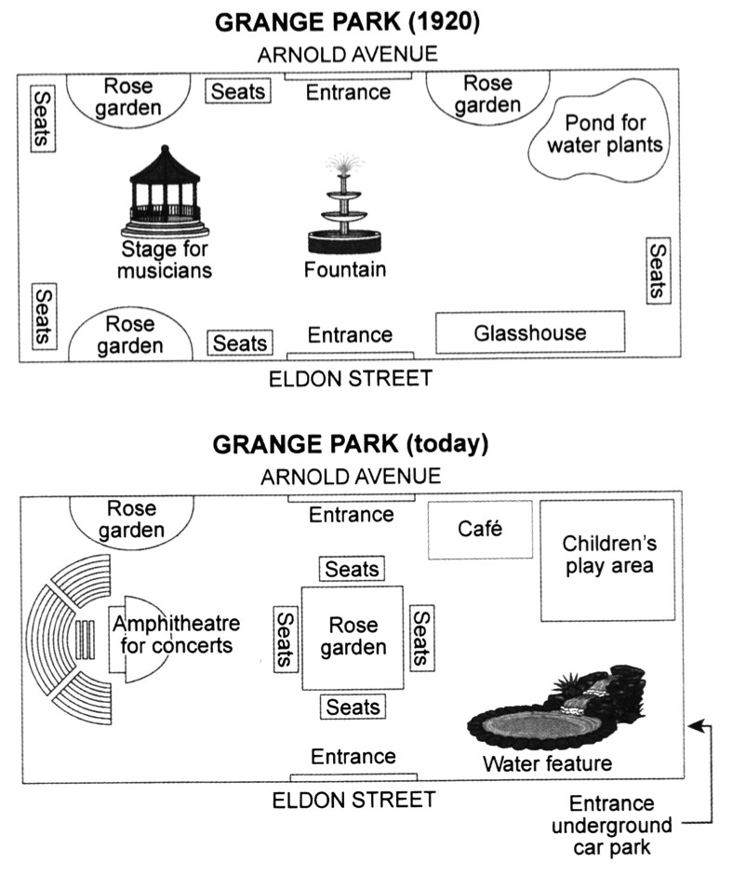

The diagrams illustrate some important changes to the Grange park area from the year 1920 to today.

It is clear that the principal change to the park will be reduction of rose garden area in number and aggregation of some of them in center of park as a larger rose garden. Various other developments is regard to seats and construction of an underground entrance for car park.

In 1920, there was an ancient structure of fountain and musician stage in center and west area. Instead, today there are a larger rose garden in square shape in center of the park which surrounded by seats and also a new amphitheatre for concerts. As can be seen in the first map, there was a pond for water plants that is disappeared with the construction of children’s play area in its place.

Looking at the maps in more detail, while the entrances still existed, an underground entrance for car park is added. Additionally, a water feature is built to the southeast of park instead of glass house in previous map.