The plans below show a public park when it first opened in 1920 and the same park today.

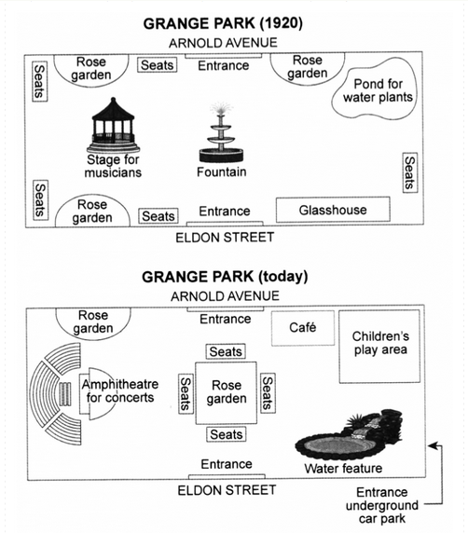

The diagrams above compares the changes that have been conducted in a public park since its opening date in 1920 until now.

It is obvious that various changes have been accomplished over a century, but there are some noticeable alterations such as building a huge Amphitheatre as well as an enormous water feature in the park beside other minor developments.

Looking at the plan of park as it is now, we can see that the central fountain has been replaced by a square shape rose garden in the middle of the park. In addition, an amphitheater for concerts is substituted to the old stage for musicians. Moreover, the pond for water plants is eliminated and now there is a children playground in the top-right corner of the park.

The number of rose gardens are decreased and one of them has changed to a café near the Arnold Avenue entrance. Furthermore, all the seats around the left edges of the park are removed and are placed surrounding the central rose garden at the center of the park. Last but not least, a new entrance underground car park is added to the south-east of the park which is accessible by the Eldon Street.