**The table below shows the numbers of visitors to Ashdown Museum during the year before and the year after it was refurbished. The charts show the result of surveys asking visitors how satisfied they were with their visit, during the same two periods.**

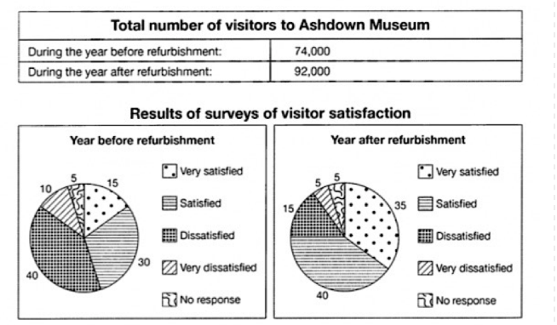

The table compares the numbers of guests who visited Ashdown Museum during the year before and the year after it was renewed. The pie charts illustrate the result of surveys about visitor's satisfaction during the same two durations.

It is clear that, in the year after refurbishment the numbers of visitors increased considerably and they were also more satisfied about their visit.

In the year before renovation, total number of guests stood at 74000. Approximately 15% of individuals were very satisfied of their visit, and just under a third of them indicated that they were pleased with their time at the museum. In contrast, half of the people showed they were dissatisfied and very dissatisfied with visiting the museum.

Regarding the year after refurbishment, visitor numbers increased to 92000. The pie chart shows that the numbers of people who are satisfied with their visit has increased significantly to more than a third (35%). In addition, proportion of very pleased guests were 40%. Total numbers of dissatisfied visitors has dropped to about 20%. Like the year before the renovation a small minority did not respond to the survey.