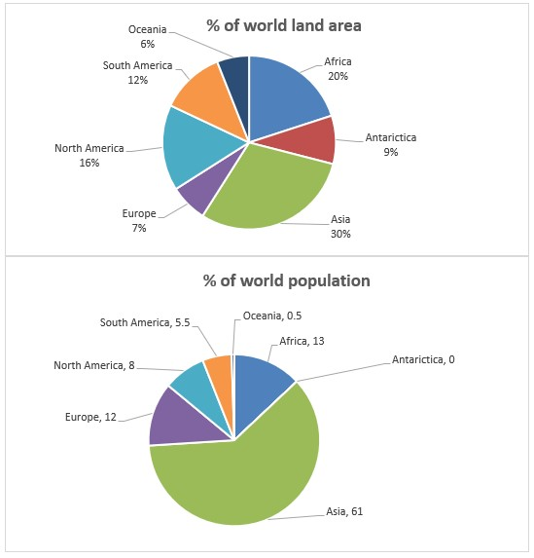

The pie charts compare two features of the seven main lands in the world, the current percentage of population and world land area.

Overall, it is clear for the largest area, Asia has the most population of total. Also, Oceania which has the lowest percentage of the population, take the smallest part of the whole land areas.

According to the pie charts, 61% of the world population is habitant in 30% of world land area, which is called Asia. The occupied areas by Oceania and Europe are approximately the same, and about 6 to 7 percent, but the percentage of their population are so different and not comparable. Also, there is a same comparison between Africa and Europe in terms of the lack of direct relation in land and population, which have almost same percentage in population, but have 20% and 7% in world land area respectively.

In addition, the rest of the world population is divided to South America and North America with 5.5% and 8% in population, 12% and 16% in world land area respectively. Although, 9% of the world lands occupied by antarctica, but there is no population in there because of the unbearable cold weather.