The table below shows the numbers of visitors to Ashdown Museum during the year before and the year after it was refurbished. The charts show the result of surveys asking visitors how satisfied they were with their visit, during the same two periods.

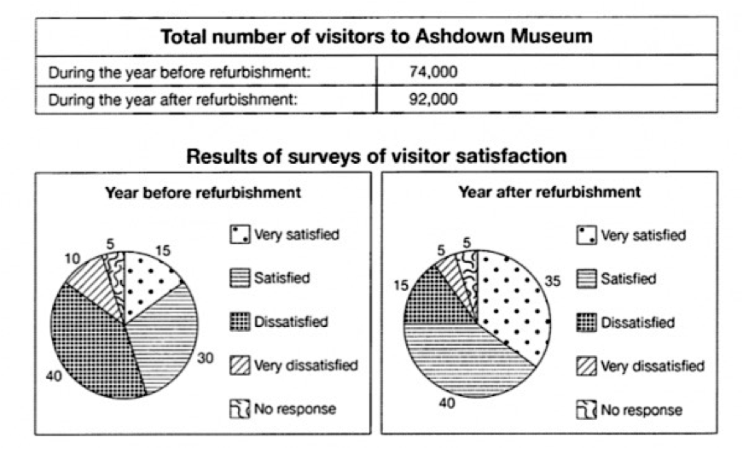

The presented table and pie charts, in combination, give information about visitors to Ashdown museum in a year before and after it was refurbished.

It is quite obvious that the refurbishment had a great positive effect on both the number of visitors and their satisfaction percentage.

During the year before the museum was refurbished, 74 thousands of people visited Ashdown museum, while this number increased to 92 thousand over the first year after the refurbishment.

Additionally, in order to measure the visitors’ satisfaction about their visit to Ashdown museum a survey was conducted, showing an overall increase in satisfaction figures. According to the results, the rate of very satisfied and satisfied visitors raised significantly from 15 to 35 and from 30 to 40 percent respectively due to refurbishment. Furthermore, the dissatisfied visitors’ percentage declined from 40 to 15 percent as well as that for very dissatisfied category which decreased from 10 to 5 percent. Meanwhile, 5 percent of the people visiting the museum in both periods did not participate in the survey.