The table below shows the numbers of visitors to Ashdown Museum during the year before and the year after it was refurbished. The charts show the result of surveys asking visitors how satisfied they were with their visit, during the same two periods.

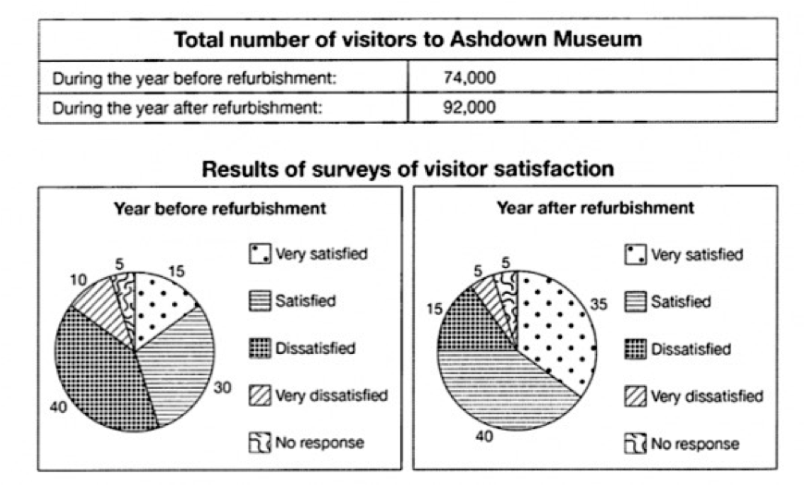

The table illustrate how many people visited Ashdown Museum in the year before and the year after its modernization. The pie charts demonstrate the responses to surveys of visitor satisfaction during the same two years.

Overall, due to the table the proportion of people who visited the Museum after renovation is more than before it. Also, according to surveys results, a large number of people expressed their satisfaction after modernization.

In the year before renovation, total visitor numbers stood at 74000. While, after modernization 18000 more visitors added to previous population.

With regards to the results of before refurbishment, 40 percent of total visitors were dissatisfied. Also, one in ten people thought they had been very dissatisfied before renovation the museum. While, the visitor surveys indicate that a third of people were satisfied. In contrast, in the year after refurbishment the number of people who were very satisfied with the change has increased from 15% to 35%. Also, the dissatisfied visitors decreased by 25%. Likewise, the proportion of people who were satisfied jumped by 10%. In both periods, 5% of people didn’t participate in the surveys.