The chart below gives data about the percentages of Internet users, categorized by age groups. Summarize the information by selecting and reporting the main features, and make comparisons where relevant.

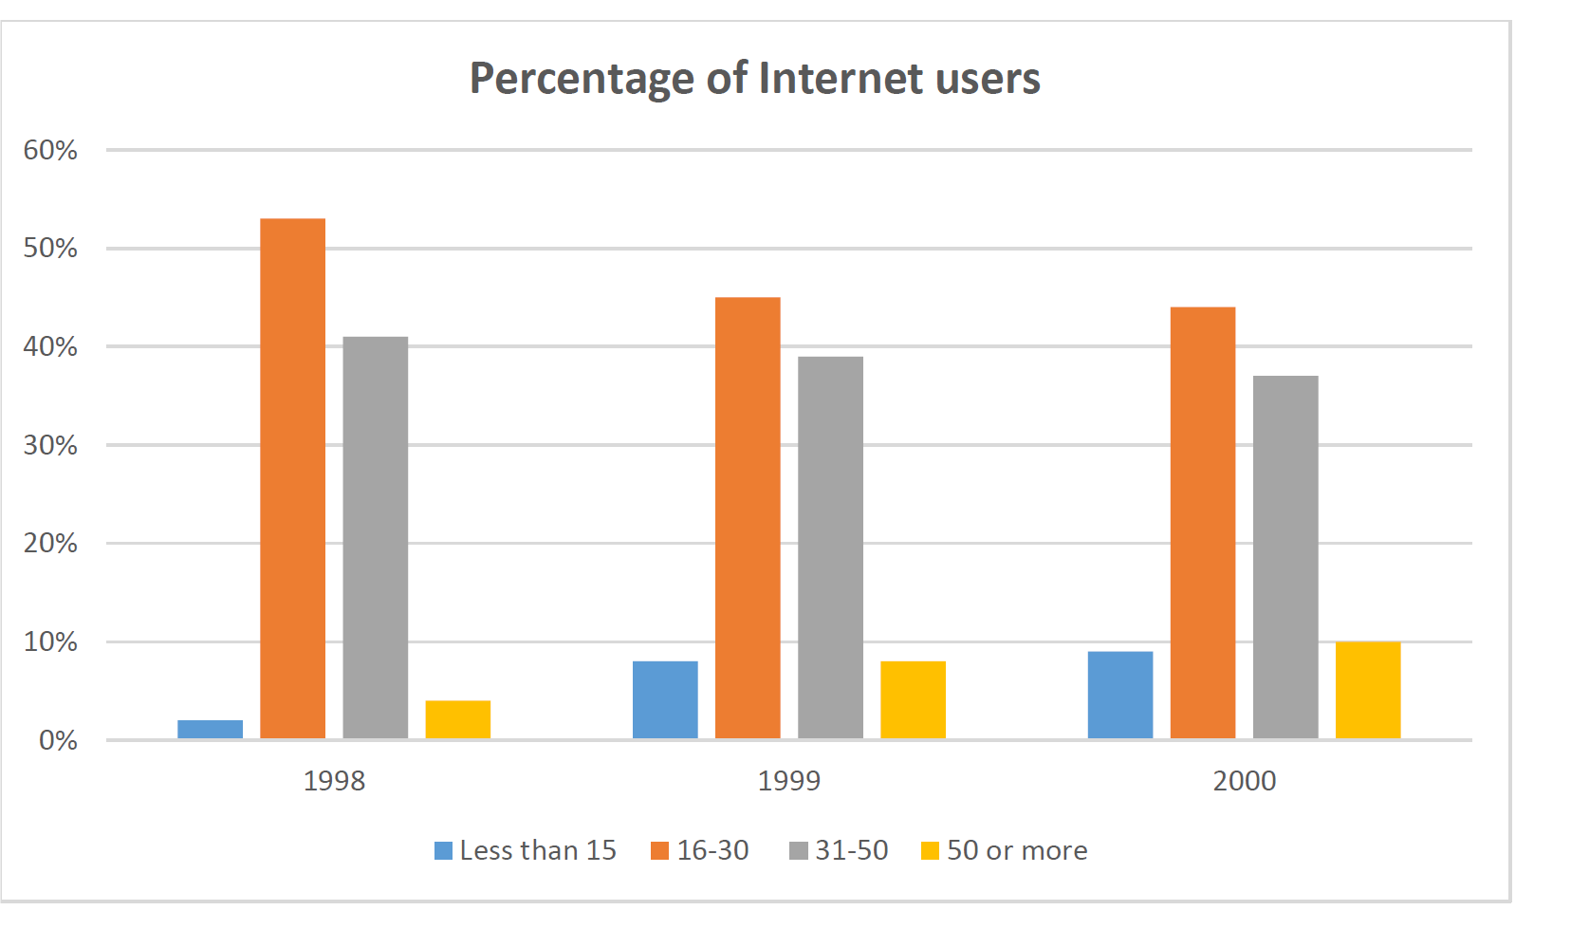

The chart compares the ratio of internet consumers in the different age groups of people from 1998 to 2000.

Following the data, internet consumption was at its lowest level among the groups of people who were under 15 and more than 50 over the periods shown. Also, the highest groups of internet users were between 16 to 50 years old in these years.

The main users of the internet were young people between 16 and 30 years old. during the years 1998 to 2000, the consumption of internet decreased from about 52% to more than 40%. The second biggest group of users was between 31 and 50 that this group consumed internet from nearly 41% to 37%, so these results showed that consumption of internet decreased slightly during these years.

However, the number of children who were less than 15, minimally increased from 2% to 8% between 1998 to 2000. There was a similar increase for adult users who were more than 50, rising from 4% in 1998 to 10% in 2000.