The chart below gives data about the percentages of Internet users, categorized by age groups. Summarize the information by selecting and reporting the main features, and make comparisons where relevant.

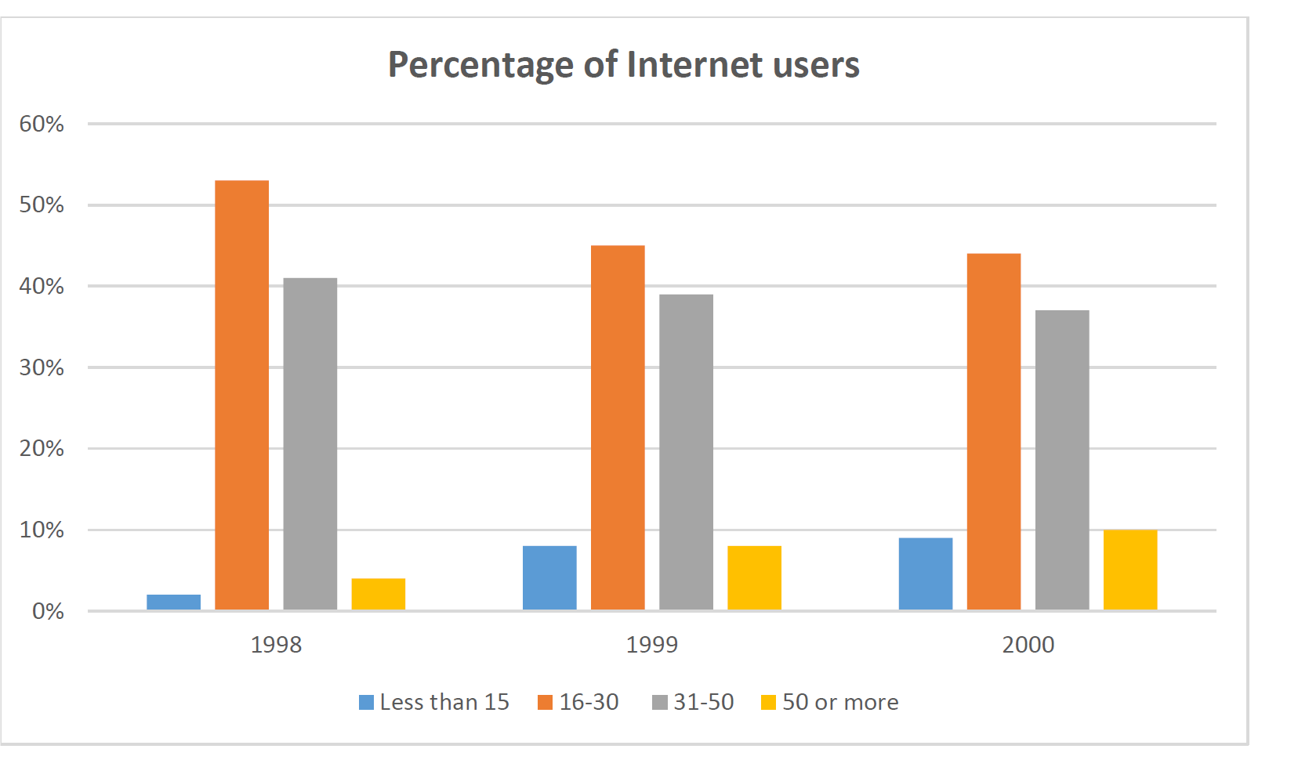

The graph below compare the percentage of internet users between 1998 and 2000 usinf four diffren ages limit

While the figures for percentage of the internet users fluctuated over the period of time

Its clear that the limit of ages between 16and 30 have the highest presentage of internet users in overall

On the other hand the limit of the ages less than 15 had the lowest percentage of the period

Ages between 16-30 had the highest percentage of internet users between 1998 and 2000

Which shown on the chart and in1998 the figure of these ages peaked nearly 55percent

The figure fore ages between 31and 50 flactuated between 35percent and 40 percent in overall

In contrast for the ages 50 or more and less than 15 the chart shows us a dramaticly growing of percentage of internet users although in compare with ages less than 15 the percentage of ages 50 and more are ended to be high in overall