The chart below gives data about the percentages of Internet users, categorized by age groups. Summarize the information by selecting and reporting the main features, and make comparisons where relevant.

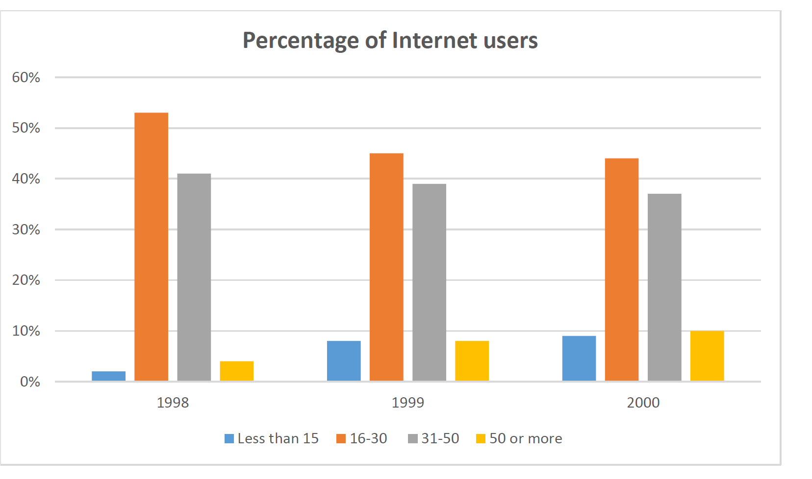

The graph shows the percentages of Internet users, categorized by 4 age groups in 3 consecutive years 1998, 1999 and 2000. Overall, it is clear that young people between the age of 16 and 30 had the highest percentage of internet users. On the other hand, children under 15 years had the lowest percentage of internet users for the majority of the period. The main users of the internet are young adults between 16_30. In 1998, the rate reached at its highest percentage, more than half of the users. In 1999, in dropped slightly to 45%. They still were the biggest group in 2000. Second biggest group of users is aged 31 and 50. They accounted for more than 40% of all users in 1998. The percentage of users decreased slightly to just under 40% in 2000. The percentage of children users increased from 2% to approximately 8% during these 3 years. More than 50-year-old people had nearly 4% of users in 1998. The rate of this group increased, and it saw a rise to almost 10% by 2000.

