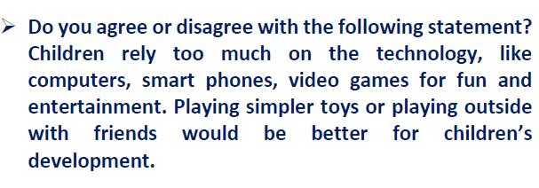
Hi
I was trying to specify some phrases, which are colored in green, that are meant to be used in every writing response.
Would you please leave me a comment whether they are placed in a suitable position?
Thank you so much.

Nowadays, observing children fiddling with their smart phones and other electronic devices is a natural habit. The more they rely on the technology, the less they become eager to play outdoors and with other toys. Despite the fact that some may propose to let them do whatever which makes them happy, I would strictly cling to the idea that pursuing this attitude will lead the children to confront serious deficient. To support this, there are several reasons to elaborate on my viewpoint, two of which are going to be appropriately explored in what follows.

To begin with, the reason why it is not a rational tenet, lies in the fact that they may become secluded. In other words, staring at a black mirror all day long not only has no benefit but also makes the child to spend most of his life solely. For instance, back then, I had a cheerful friend, which was my classmate at school. In that time, our major amusement was hanging out and having fun with each other. As the time passed, he bought a gaming console named “Play Station 4”. Now, each time we ask him to hang out, he just makes an unacceptable excuse to get rid of us. It seems that he is glued to that console, which is consuming his life. However, he is still one of our friends. Therefore, we insisted on seeing him while he was expressing his reluctance. Sometimes we force him to visit us, But the result is sitting next to a lonely silent object. As you can see, did he not buy that console, none of these would happen.
Another noteworthy reason to be mentioned is that playing other games not only help improving creativity but also may enhance the body health status. To clarify this, playing outdoor games is a kind of exercising. Therefore, by playing these games such as football and so forth, having fun and keeping health condition appropriate can be obtained in the same time. In addition, some boardgames and simple toys will stimulate a child’s creativity. Take my nephew, which is only three years old, as a relevant example, he is not allowed to use smartphones and television more than half an hour each day. Therefore, he has to amuse himself by playing with his toys and doing games with us since video games are prohibited. As a result, he is a smarter and healthier boy in compare with other children with the same age. This experience taught me, many acts, which are thought-provoking, are necessary for children to be performed.

Taking everything into consideration, the aforementioned reasons help us conceive that attending the games, which cease to perform other vital tasks, will disrupt one’s daily-life. Moreover, having fun with other things will be recorded in one’s mind and will make life more pleasant. As a consequence, due to the mentioned facts, sticking to these things will lead children enhance both their mental and physical body performance.

491 70min

